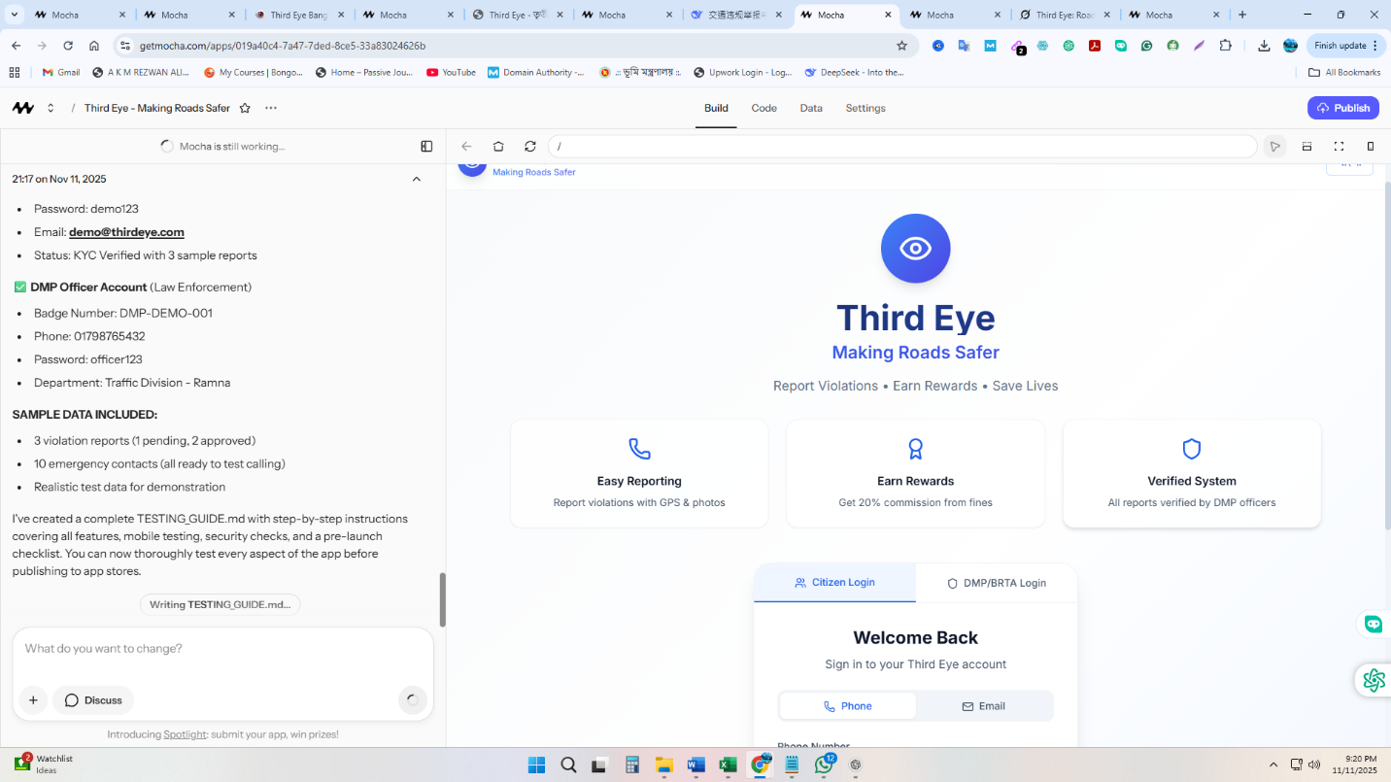I'll create a demo account with pre-populated data so you can test all features before publishing.
Demo account created successfully!
Demo Account Credentials:
- Mobile Number: 01712345678
- Password: Demo123!@
What's included in the demo account: ✅ Fully verified user with KYC and biometric verification ✅ 5 sample traffic violation reports:
- 2 Approved cases (with ৳2,000 total rewards)
- 1 Pending case
- 1 Under Review case
- 1 Rejected case (with reason) ✅ Connected bKash wallet ✅ 3 sample notifications ✅ Complete profile with all features accessible
You can test:
- Login with demo credentials
- View dashboard with stats and cases
- See different case statuses
- Check notifications
- Test profile settings (edit profile, change password with OTP)
- Try wallet features
- Create new reports
- Test PWA installation
- Navigate through all pages with back buttons
- Test account deactivation/deletion (optional)
The demo account has realistic data so you can experience the full app functionality before publishing.

